**Speed Control of Double Acting Cylinder**

Roll no: 2022-MC-58

**Objective:**

To Control the speed of Double Acting Cylinder, such that the forward moving speed is double of reverse Speed.

**Equipment’s and parts:**

* Double acting cylinder
* 3/2 Pneumatic Valve
* Flow Control Valve
* Connecting Pipes
* Mechanical push button
* Fluid (Air) Reservoir
* Regulator
* Air distributer (Multi diameter pipes Junction)

**Working Explanation:**

The air goes to Flow Control Valve by connecting Pipes, from there it goes to Pneumatic Valve. The output of this Valve is connected to the Push Button which is connected to cylinder for its Reverse Motion. For its forward motion, air from reservoir is connected to Push Button and Supplied to Cylinder.

**Circuit Diagram**

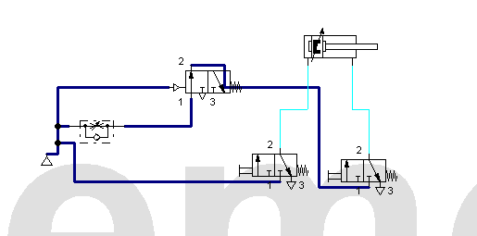

Speed Control of Double Acting Cylinder

**Conclusion:**

We learned the principle of flow control valve and its interfacing with 3/2 Pneumatic Valve. We controlled the speed of double acting cylinder in such a way that its retract speed is half of its extend speed.